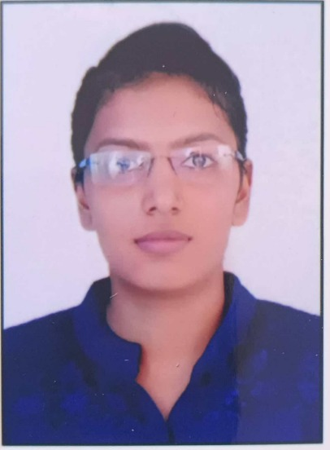
- Name :- Ms Madhvi Rajeshbhai Patel
- Date of Birth :- 25/04/1999
- Email :-guddy25patel04@gmail.com
- Educational Qualification :- B.Pharm , M.Pharm
- Work Experience:-

- Teaching: 0
- Hospital : 1 yr

- Area of Specializations:- Pharmaceutics

Subjects teaching at Under Graduate Level:
- Pharmaceutics I
- Physical Pharmaceutics I
- Pharmaceutical Inorganic chemistry
- Integrated personality development course

- Project carried out:- M.Pharm

Formulation and Evaluation Artesunate sustained release matrix tablet

